
CHEMISTRY


CHEMISTRY
2019 PRACTICE TEST

Question Booklet 1
- Part 1 (Questions 1 to 5) 40 marks
- Answer all questions in Part 1
- Write your answers in this question booklet
- You may write on page 12 if you need more space
- Allow approximately 52 minutes
- Approved calculators may be used – complete the box below

Examination Information
Materials
- Question Booklet 1 (Part 1)
- Question Booklet 2 (Part 2)
- Periodic Table

Writing time
- 40 minutes – Booklet 1 (Summative)
- 60 minutes – Booklet 2 (Formative)
- Clear, well-expressed answers are required
- Use black or blue pen

Total marks = 99

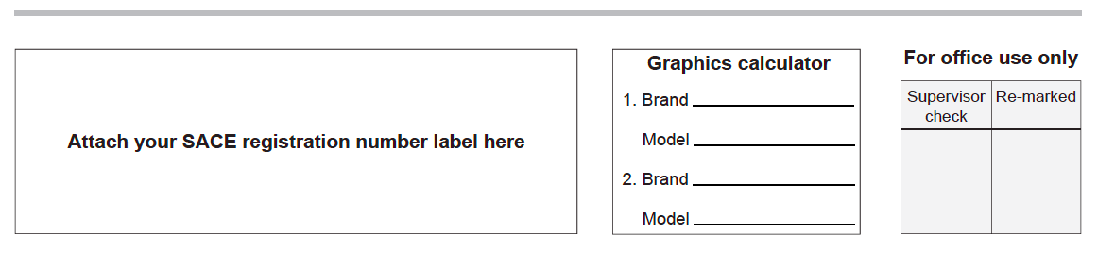

QUESTION 1 (10 marks)

(a) Dinitrogen tetroxide (N₂O₄) is a colourless gas that dissociates to give nitrogen dioxide (NO₂), a dark brown gas, according to the following equation:

N₂O₄ _{(g)} $⇌$2NO₂ _{(g)}

The changes in the concentrations of the two gases with time in two experiments, 1 and 2, are shown below:

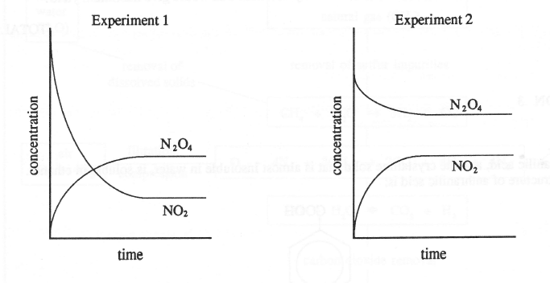
(i) Describe the colour changes that would be observed in experiment 1

______________________________________________________________________

______________________________________________________________________
(2 marks)

(ii) In a third experiment, conducted at 25⁰C, 0.0300 mol of nitrogen dioxide and 0.500 mol of dinitrogen tetroxide were placed in a vessel of I litre volume. After the reaction reached equilibrium it was found that the vessel contained 0.491 mol of dinitrogen tetroxide.
State the expression for the constant, Kc, for the reaction

N₂O₄ _{(g)} $⇌$ 2NO₂ _{(g)}

(2 marks)

(iii) Complete the table below and hence calculate the value of Kc for the reaction at 25⁰C.

Concentration | 2NO₂ _{(g)} | N₂O₄ _{(g)}
Initial
Change
Final

(3 marks)

(iv) The pressure of the equilibrium mixture in (ii) above is suddenly increased by reducing the volume to about 250 mL and is then allowed to reach equilibrium once more at 25⁰C.
Predict and explain the colour change that would be observed.

_____________________________________________________________________

_____________________________________________________________________

_____________________________________________________________________

_____________________________________________________________________

_____________________________________________________________________

____________________________________________________________ (3 marks)

QUESTION 2 (9 marks)

The production of nitric acid in a factory is summarized in the flow chart below:
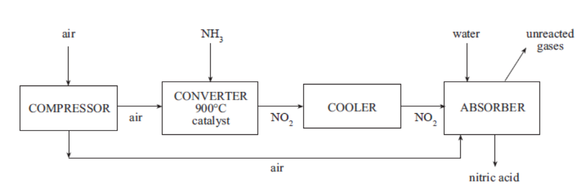

- (i) Explain the benefit of compressing the air prior to converting ammonia to NO₂
_______________________________________________________________________

________________________________________________________________________

____________________________________________________________(2 marks)(KA1)

(ii) Nitrogen dioxide is added to the absorber, where nitric acid is produced. Identify the other reactant added at this step.
____________________________________________________________(1 mark)

(iii) Identify what gas has been recycled.
____________________________________________________________(1 mark)

(iv) Explain the environmental and economic benefit behind maintaining a converter temperature at 900°C.

_______________________________________________________________________

_______________________________________________________________________

________________________________________________________________________

____________________________________________________________(2 marks)(KA1)

- The production of nitric acid has been the subject of close scrutiny in the US. Due to the levels of emissions of NO₂ that have been detected during the production of nitric acid, the levels are high. Protocols have now been developed which require the absorber to contain secondary conversion catalysts.

Describe how the development of scientific knowledge may have beneficial or unexpected consequences from the close scrutiny.

________________________________________________________________________

________________________________________________________________________

________________________________________________________________________

________________________________________________________________________

________________________________________________________________________

________________________________________________________________________

____________________________________________________________(3 marks)

QUESTION 3 (8 marks)

Bromomethane, CH₃Br, is a toxic, odourless and colourless gas. It is used by quarantine authorities to kill insect pests.

A simplified reaction for its synthesis is.

$${CH}_{3}{OH}_{(g)}+ {HBr}_{(g)} ⇌ {CH}_{3}{Br}_{(g)}+{ H}_{2}O_{(g)} ∆H= -37.2 kJ{mol}^{-1}$$

The manufacturer of this chemical investigates reaction conditions that could affect the time the process takes and the percentage yield.

- Predict the effect of each change below on the rate of production of bromomethane.

- Increasing the temperature (constant volume). Justify your reasoning.

__________________________________________________________________

__________________________________________________________________

______________________________________________________(2 marks)(IAE3)

(ii) Increasing the pressure (constant temperature). Justify your reasoning.

__________________________________________________________________

__________________________________________________________________

______________________________________________________(2 marks)(IAE3)

- The graph below represents the concentration of three species involved in the production of CH₃Br when they are at equilibrium at constant temperature. At time t₁, a small amount of Br was suddenly added to the equilibrium mixture.
Complete the graph after t₁, showing the changes in concentration for each of the three species.
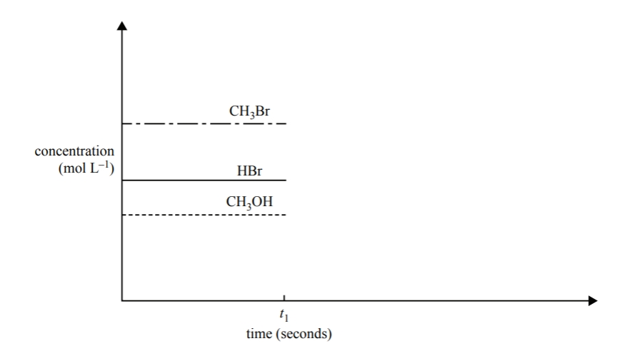
(3 marks)
- When bromomethane is used by quarantine officers, it is pumped into a sealed room that contains the items to be treated.

Describe one safety precaution that quarantine officers would need to consider when using bromomethane.

_________________________________________________________(1 mark)

QUESTION 4 (14 marks)

Credit will be given for the correct use of significant figures in calculations in answers to part (a)

Proteins are important biological compounds.

- The nitrogen content of a sample of dried protein, with a mass of 0.895g, was determined by converting all the nitrogen in the protein into ammonia gas, NH₃.

The ammonia was then bubbled through 50.0 mL of 0.1970 mol L⁻¹ HCl solution. A reaction occurred, as shown in the equation below:

NH₃ + HCl NH₄⁺ + Cl⁻

(i) Calculate the initial number of moles of HCl present before the reaction with ammonia.

(2 marks)(KA4)

(ii) After the ammonia had reacted, excess HCl remained. The excess HCl was neutralised by titration with 5.90 mL of 1.000 mol L⁻¹ NaOH. A reaction occurred, as shown in the equation below:

NaOH + HCl NaCl + H₂O

Calculate the number of moles of NaOH that were used.

(1 mark)(KA4)

(iii) Hence determine the number of moles of excess HCl.

(1 mark)(KA4)

(iv) Calculate the number of moles of HCl that reacted with the NH₃
(1 mark)(KA4)

(v) Hence determine the number of moles of NH₃ that reacted with the HCl solution.

(1 mark)(KA4)

(vi) Calculate the mass of nitrogen in the sample of dried protein.

(2 marks)(KA4)

(vii) Calculate the percentage mass of nitrogen in the sample of dried protein.

(2 marks)(KA4)

QUESTION 5 (8 marks)
Credit will be given for answers that are coherent and contain only relevant information.

Sulfur dioxide (SO₂) is an important industrial gas that is also found in small quantities in the earth’s atmosphere. The major use of SO₂ is in the manufacture of sulfuric acid by the contact process. The following equation describes one step in this multi-step process:
Vanadium Catalyst
2SO_{2(g)} + O_{2(g)} 2SO_{3(g)} ΔH = -99 kJ mol⁻¹

- Explain why high pressure leads to an increased rate of reaction.
- Explain how increasing the temperature of the reaction vessel affects the amount of SO₃ produced.
- Describe one economic advantage and disadvantage of using a catalyst in this reaction.
________________________________________________________________________

________________________________________________________________________

________________________________________________________________________

________________________________________________________________________

________________________________________________________________________

________________________________________________________________________

________________________________________________________________________

________________________________________________________________________

________________________________________________________________________

________________________________________________________________________

________________________________________________________________________

________________________________________________________________________

________________________________________________________________________

________________________________________________________________________

________________________________________________________________________

________________________________________________________________________

________________________________________________________________________

____________________________________________________________(8 marks)(KA4)

You may write on this page if you need more space to finish answers to Question Booklet 1. Make sure to label each answer carefully (e.g. 2(b) continued).
________________________________________________________________________

________________________________________________________________________

________________________________________________________________________

________________________________________________________________________

________________________________________________________________________

________________________________________________________________________

________________________________________________________________________

________________________________________________________________________

________________________________________________________________________

________________________________________________________________________

________________________________________________________________________

________________________________________________________________________

________________________________________________________________________

________________________________________________________________________

________________________________________________________________________

________________________________________________________________________

________________________________________________________________________

________________________________________________________________________

________________________________________________________________________

________________________________________________________________________

________________________________________________________________________

________________________________________________________________________

________________________________________________________________________

________________________________________________________________________

________________________________________________________________________

________________________________________________________________________

________________________________________________________________________

